REPORT

1) **[solution,score]=ga_mapcoloring();**

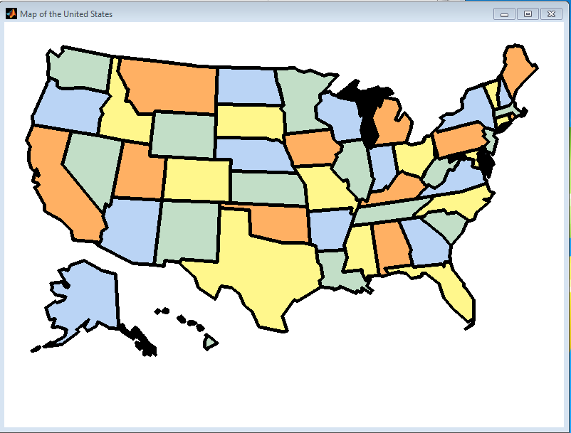

The particular map has zero error, score=0; It took 23 iterations to complete.

No changes were made to the recommended parameters, **except TOURNAMENT=5 initilally**🡪 this gave better results.

(a)

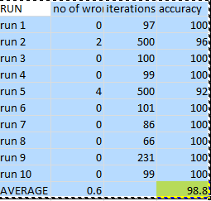

Mean score of wrong items=0.6

Mean score of correct items=49.4

b)

Yes the results match my intiution.This is because more is the no of iterations more difficult it is to find the correct mapping.Had I inscresed the number of iterations the accuracy would have ben better.

c) you can run this by using the following code

**[solution,score]=ga_mapcoloring_2();**

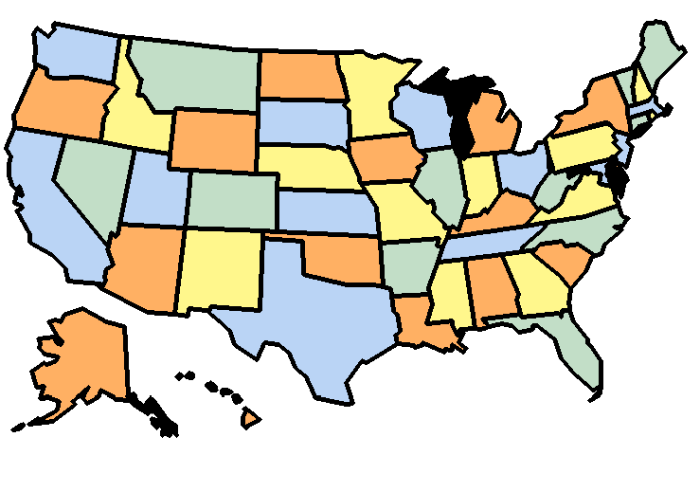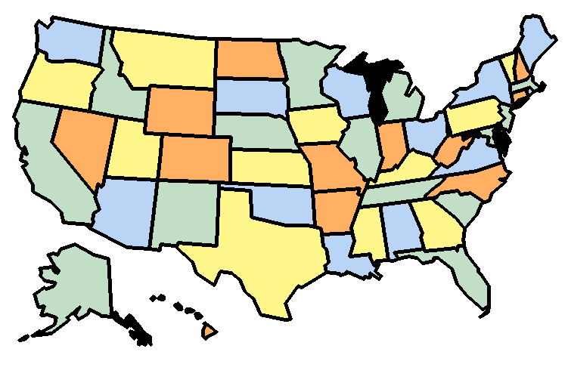

Case 1 case 2

|  |  |  |  |  |  |  |
| --- | --- | --- | --- | --- | --- | --- |
|  | population | offspring size | tournamnet | iterations | score | time |
| case 1 | 100 | 98 | 2 | 500 | 48 | less |
| case 2 | 1000 | 998 | 20 | 500 | 46 | more |

More pop and less pop both have negative impact on the algorithm.

d) I can keep running the code until the 33 and 40th have a value of 1

**Please check ga_mapcoloring_partd()**